Assingment-6
Task Description-1 (Classes – Data Validation)
Prompt: name, roll_no, and marks. Add a method is_pass() that returns whether the student has passed (marks ≥ 40).
Code:
class Student:
def __init__(self, name, roll_no, marks):
self.name = name
self.roll_no = roll_no
self.marks = marks

def is_pass(self):
return self.marks >= 40

student = Student(“Sujithh", 396, 96)

print("Name:", student.name)
print("Roll No:", student.roll_no)
print("Marks:", student.marks)

if student.is_pass():
print("Result: Pass")
else:
print("Result: Fail")
Output: 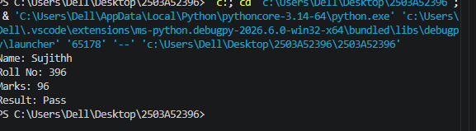

Task Description-2 (Loops – Pattern Generation)
Prompt: Ask AI to generate a function that prints a right-angled triangle star pattern using a for loop. Then regenerate the same pattern using a while loop.
Code:
def print_triangle_for_loop(rows):
for i in range(1, rows + 1):
print("*" * i)

#Here is a function that prints a right-angled triangle star pattern using a while loop:
def print_triangle_while_loop(rows):
i = 1
while i <= rows:
print("*" * i)
i += 1
#example usage
print("Triangle using for loop:")
print_triangle_for_loop(5)
print("Triangle using while loop:")
print_triangle_while_loop(5)
Output:

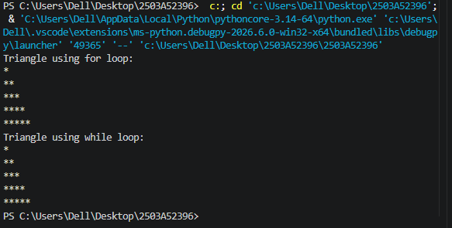

TaskDescription-3 (Conditional Statements – Number Analysis)
Prompt: Ask AI to write a function that checks whether a given number is positive, negative, or zero using if-elif-else. Test the function with multiple inputs
Code:
def check_number(number):
if number > 0:
return "Positive"
elif number < 0:
return "Negative"
else:
return "Zero"

print(check_number(10))
print(check_number(-5))
print(check_number(0))
Output:
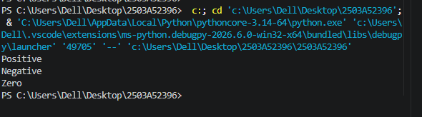

Task Description-4 (Nested Conditionals)
Prompt:
Generate a function check_discount(age, is_member) that determines discount eligibility:
Age ≥ 60 → Senior discount
Member → Additional discount
Use nested if statements.
Code:
def check_discount(age, is_member):
if age >= 60:
if is_member:
return "Senior Discount + Member Discount"
else:
return "Senior Discount"
else:
if is_member:
return "Member Discount"
else:
return "No Discount"

print(check_discount(65, True))
print(check_discount(65, False))
print(check_discount(30, True))
print(check_discount(30, False))
Output:
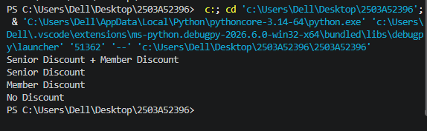
Task Description-5 (Class – Mathematical Opera)
Prompt: Ask AI to create a Circle class with methods to calculate area () and circumference () given the radius.
Code:
import math

class Circle:
def __init__(self, radius):
self.radius = radius

def area(self):
return math.pi * self.radius ** 2

def circumference(self):
return 2 * math.pi * self.radius

circle = Circle(5)

print("Radius:", circle.radius)
print("Area:", round(circle.area(), 2))
print("Circumference:", round(circle.circumference(), 2))
Output:
